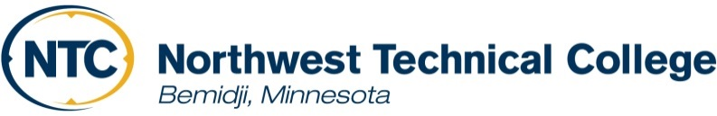
2023 Summer Financial Aid Award Notice Information

Financial Aid Disbursement and Payment

Disbursement of summer financial aid begins May 26, 2023. You must register for all summer classes (for all enrollment periods) prior to receiving your aid. All financial aid funds, including grants, loans, and third-party agency awards are first applied against direct school costs. If applicable, any overage of funds will be disbursed May 26, 2023, unless your classes have not started. If this is the case, the earliest your aid can be disbursed is 10 days before the first class begins. A check will be mailed to your permanent address if you are not signed up for direct deposit. If you have at least one NTC course in the summer term, you may charge your books to your NTC student account at the NTC on-campus bookstore from April 17 - May 19, 2023. Financial aid at NTC will only automatically be applied to my bill at NTC. You are responsible to pay all other school bills out-of-pocket or with any disbursed financial aid.

Federal Direct Loan
If you wish to receive a summer Federal Direct Loan, review your Summer Financial Aid Award Notice and follow the instructions to accept a Federal Direct Loan online. First time Direct Loan borrowers must complete loan entrance counseling and a Master Promissory Note (MPN) for a Subsidized/Unsubsidized Loan - prior to disbursement of loan funds. Go to https://studentaid.gov (Popular Topics) to sign the MPN using your FSA ID. Loan Entrance Counseling is located at the same web site under the In School tab and listed under Popular Topics.

Returning students and/or borrowers, disbursement of any financial aid that is left over after tuition, fees and any books that were charged will be available to you approximately three weeks after the start of each semester. Financial Aid overage can be directly deposited, or a check could be mailed to your permanent address.

Satisfactory Academic Progress (SAP)
A satisfactory academic progress review for financial aid is conducted immediately after spring grades are processed. If you are found to be below the standards for aid (GPA, percent completion rate, or maximum time frame), your summer financial aid could be cancelled. The Satisfactory Academic Progress Policy can be found at: http://www.ntcmn.edu/myntc/finances/aid/forms-policies/.

Outside Agency Funding
If you anticipate receiving funding from an agency such as VRS, CEP, JTPA, TAA, tribal or a scholarship for the summer, be sure this funding is indicated on your award notice. If it is not on your award notice, notify the Financial Aid Office immediately at (218) 333-6600.

Enrollment Changes
Cancellation of a class or change in your enrollment after your aid is processed (including withdrawn courses), regardless of the reason, will result in a recalculation of your eligibility. If the recalculation results in an over award, you may become ineligible for aid you have already received. Please notify the Financial Aid Office if you change your enrollment after your aid has been determined.

