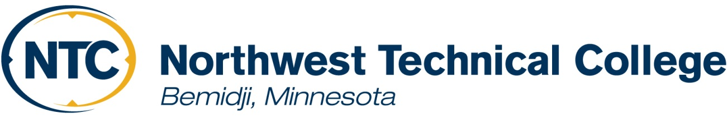

2022-2023
Financial Aid Information

Seeking a college education may be a financial challenge to a student and their family. Financial assistance may be available based on financial eligibility. Students interested in applying for financial assistance must complete the Free Application for Federal Student Aid (FAFSA). The U.S. Department of Education determines the financial need from your information on the FAFSA.

Financial Aid Application Checklist

Summer 2022 Students: Please complete 2021-2022 Application process (2021-2022 FAFSA using 2019 tax information and other institutional requirements). You will also need to complete the 2022 Summer Supplemental Application available in April 2022 from the Financial Aid Office. Please contact the Financial Aid Office with questions.

Fall/Spring 2022-2023
❑ Apply for admission to Northwest Technical College online at www.ntcmn.edu/admissions/.
❑ Submit copies of all college transcripts to the Admissions Office.
❑ Complete the 2022-2023 FAFSA or Renewal FAFSA on the Web at www.fafsa.gov using 2020 Federal tax information. You are encouraged to use the IRS Data Retrieval Tool that is part of FAFSA on the Web. This tool can be used for students and/or parents if applicable.
❑ Northwest Technical College’s Federal school code for the FAFSA application is 005759.
❑ Continue to check your application status with the Financial Aid Office or online (Under MyNTC, e-Services, Financial Aid). Your application is not complete until you receive a financial aid offer, accessible through your e-Services account.
❑Compare your financial aid approved awards with your bill to determine if you will need to cover costs out-of-pocket.

FAFSA Priority Deadlines:

Fall Semester 2022 – March 1, 2022
Spring Semester 2023 - November 1, 2022
Summer Semester 2023 - March 1, 2023

Important Notice: If you are applying for financial aid after any of the above semester deadlines, you will be considered a late applicant. This means that any financial aid for which you are eligible may not arrive in time to pay for your semester expenses. If this happens, you may need to cover some costs out of pocket until your financial aid arrives.

Financial Aid Requirements

- You must declare a program major.
- You may receive financial aid for only the required courses in your program and required college readiness courses.
- You must have completed the admissions process.
- You must be enrolled in a minimum of 6 credits per semester to be eligible for work-study, child care funds, and loans.
- You may not receive more financial aid (including loans) than the established institutional budget (please contact the Financial Aid Office for assistance).
- All loan borrowers must complete the Annual Student Loan Acknowledgement https://studentaid.gov/asla/.
- First time borrowers at NTC must complete the Loan Agreement for Subsidized/Unsubsidized Loan (MPN) and Entrance Loan Counseling at: www.studentaid.gov.
- A completed FAFSA must be received by the Federal Aid Processing Center within the first 30 days of the semester to be eligible for a Minnesota State Grant.
- Your financial aid may be impacted if you stop attending or withdraw from your courses.
- In order to receive financial aid, you must maintain satisfactory academic progress. (View the Satisfactory Academic Progress Policy for Financial Aid at: http://www.ntcmn.edu/myntc/finances/aid/forms-policies/).
- Your financial aid will be applied automatically to your bill at NTC. Bills from all other institutions will not be automatically paid, including BSU.

Financial Aid Disbursement
- For first year, first-time direct loan borrowers (or previous borrowers with no outstanding balance): your direct loan disbursement will be processed approximately 30 days after the start of the semester.
- Returning students and/or borrowers, disbursement of any financial aid that is left over after tuition, fees and any books that were charged will be available to you approximately 3 weeks after the start of each semester. Financial Aid overage can be directly deposited or a check could be mailed to your permanent address.
- Single-term loans will be a split disbursement at the beginning of the semester (depending on first-time borrower or returning borrower status) and the remaining half at the midpoint of the semester.
Check Your Status Online
Once you are admitted to NTC, you can go to www.ntcmn.edu, click on MyNTC, e-Services, and log-in. You can view your financial aid status, your award letter, your bill, and other useful information.

Tuition Payment Policy
For Fall 2022 semester, you will be dropped for non-payment on August 1 unless you have met one of the following conditions:
- The FAFSA form has been completed, and the results are on file in the Financial Aid Office (financial aid processing does not have to be complete, just a FAFSA needs to be on file).
- A $300 down payment or 15% of tuition and fees has been paid to the Business Office.
- Third party billing authorization has been submitted to the Business Office.
Online Classes Taken Through Other Institutions
Your financial aid may help cover online course taken at different schools, but your financial aid does not automatically pay other school bills. If you have a bill at another school, you will need to pay that school on your own, or use your financial aid disbursement.

NTC Financial Aid Office
905 Grant Ave SE * Bemidji, MN 56601
218-333-6654 * FAX: 218-333-6698 * Email: finaid@ntcmn.edu

