Sponsorship Agreement

Sponsor – Company name: Contact:
Address: City: _ Zip:
Phone number: Email:
Please indicate how you would like your name/company listed for recognition, or indicate anonymous:

Donation Level (circle your choice):
Gold Sponsorship of $500 or higher includes:
- One exhibit table
- Ability to include promotional material in attendee welcome packet
- Link from Conference website to Sponsor’s website
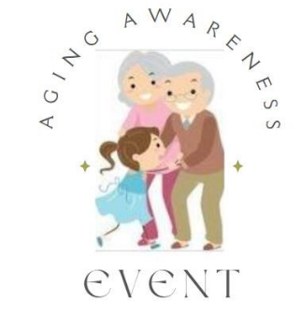
- Logo displayed in printed program and onsite signage

Silver Sponsorship of $250 includes:
- One exhibit table
- Link from Conference website to Sponsor’s website
- Logo displayed in printed program and onsite signage

Bronze Sponsorship of $50 includes:
- One exhibit table

Signature: ______________________________________ Date: ____________________

- Make checks payable to: Northwest Technical College
- Sponsorship forms and checks may be mailed to: Northwest Technical College, Attn: Aging Event Sponsorship, 905 Grant Ave. SE, Bemidji, MN 56601
- If you have questions about sponsorship or need to request an invoice, please contact:
Sarah Behrens, Sarah.behrens@ntcmn.edu or (218) 755-4902

You will receive a follow-up email with instructions for submitting your logo and how to access any registrations.

PLEASE RETURN NO LATER THAN September 1ST, 2022

