**Sponsorship Opportunities**

# Aging Awareness Event

**September 28, 2022**

*Be a part of bridging the generation gap in greater Minnesota!*

**Gold Sponsorship of $500 or higher includes**:

* One exhibit table
* Ability to include promotional material in attendee welcome packet
* Link from Conference website to Sponsor’s website
* Logo displayed in printed program and onsite signage

**Silver Sponsorship of $250 includes**:

* One exhibit table
* Link from Conference website to Sponsor’s website
* Logo displayed in printed program and onsite signage

**Bronze Sponsorship of $50 includes**:

* One exhibit table

North Country Vocational Cooperative Center

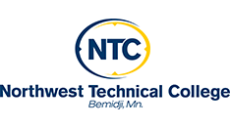

For more information and **to reserve your Event Sponsorship, please contact us**

**NO LATER THAN SEPTEMBER 1ST, 2021**

Sarah Behrens at [sarah.behrens@ntcmn.edu](mailto:sarah.behrens@ntcmn.edu) 218-755-4902