Registration

To get started, click the link provided to you by the organization offering scholarships. This will bring you to the Logon Page. Then follow these steps to get set up to apply:

- If this is your first time logging into the site, click Create New Account.
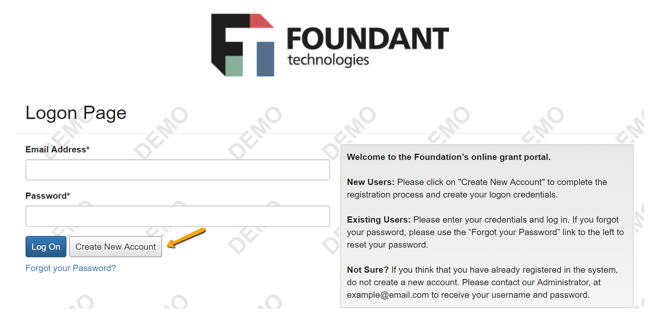
- You’ll land on the Registration page. Any fields with an asterisk are required.
  - You may see the option to connect to Scholar Snapp. If you have a Scholar Snapp profile, you may use it to help fill out this registration page. Click Connect to Scholar Snapp and follow the instructions in the pop-up box.
    - There may also be questions on the scholarship application form that allow you pull in responses from your Scholar Snapp profile.
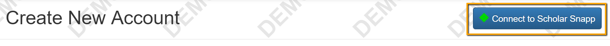
  - After completing the fields on this page, click Next.
- Create a password. Requirements for the password are listed above the text boxes.
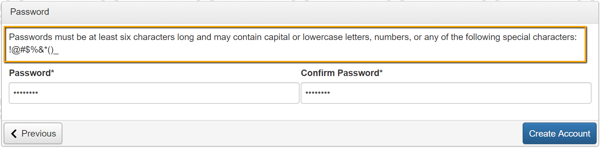
- Click Create Account to finish registration.

- The next page asks you to confirm that you’ve received a confirmation email. Follow the instructions on that page before moving forward.
  - This step is important to make sure that you can receive other emails about your scholarship applications and possible awards.
  - Click Continue after following the instructions.
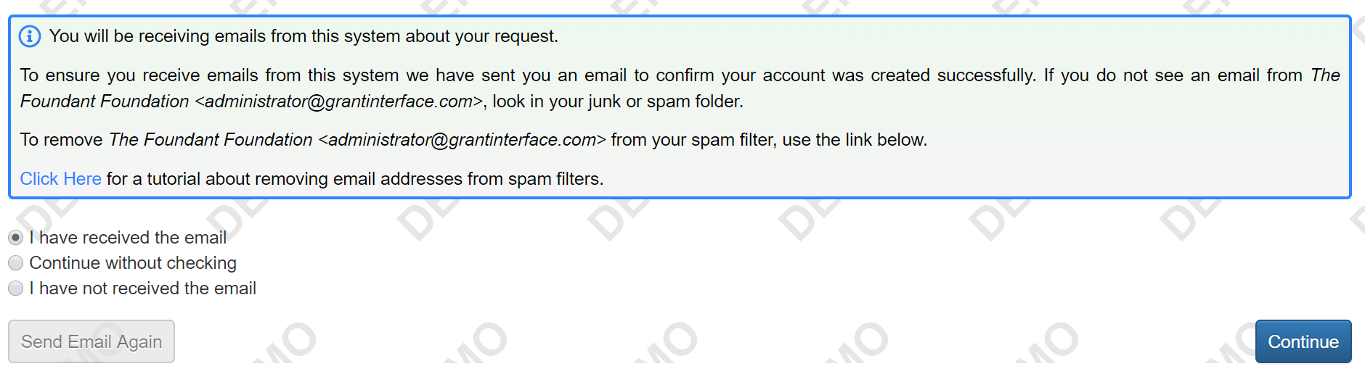
- Now that you’ve created your account, when you visit the site again you can enter your email address and password, then click Logon.
  - If you forget your password, the Forgot your Password link will step you through resetting it.

Applying

- After logging into the site, click Apply in the top navigation bar to view open opportunities.

- Click Apply next to an opportunity to begin an Application.
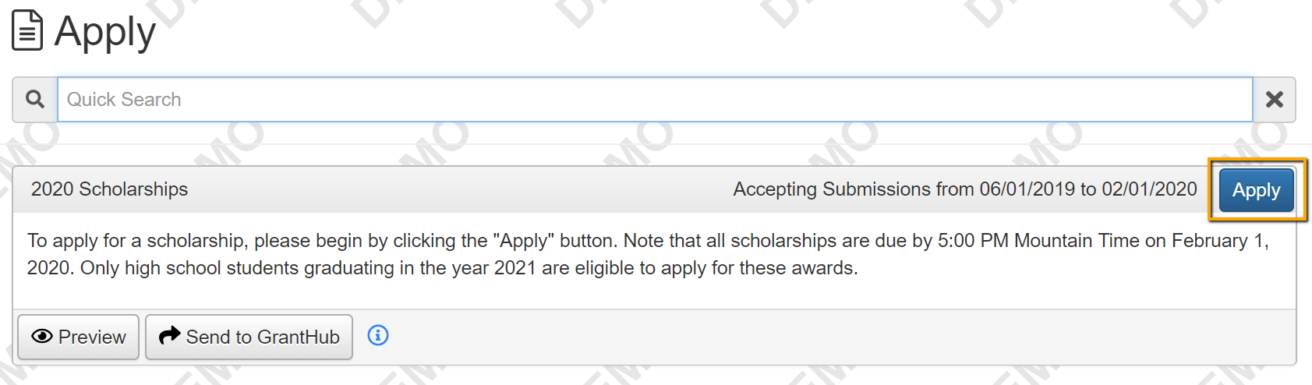

- If the Application has a due date, you will see it listed at the top of this form.
  - Please be aware that you may not be able to submit your Application after the deadline, depending upon how the organization has set up the due date.
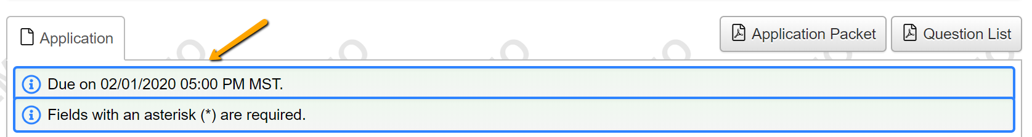

- Fill out the Application form. Any questions with an asterisk next to them are required.
  - Questions with character limits will show an error message if your response is over the limit.
    - You will need to shorten your response to fit within the limit before you can submit your Application.
  - File upload questions will only accept one file per question, and there will be a file MiB limit noted.
    - If you upload a file that’s too large or an unaccepted file type, a warning will appear, and your file will not be saved.
- If you have a Scholar Snapp profile, you may click Copy Scholar Snapp Profile to pull in responses to questions on the Application with the Scholar Snapp icon (). Some Applications may not include any of these questions.
  - If you edit any of these responses on the Application, you can click Update Scholar Snapp at the bottom of the page to push your edited responses back to Scholar Snapp.
    - Note that some questions (for example, essay questions) pulled from Scholar Snapp will not push back with edits you made on your Application.
- The Application may contain one or more sections to be completed by another person, for example someone who will write you a letter of recommendation. You’ll see instructions on the Application if this is the case.
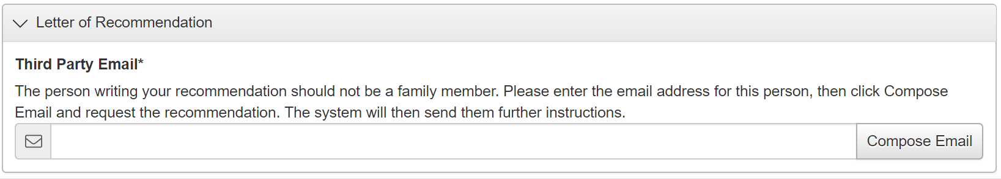
  - After typing in the email address for the person who will complete that section for you, click Compose Email.
    - In your email, let them know what you need, and include any other information as instructed on the Application.
  - The system will then send them another email with a link to complete the questions in that section.
  - You won’t see the questions in that section, but you can see whether or not they’ve been completed.

    - Unless the organization gives you other instructions, you can submit your Application before this person completes their section.
- The system will autosave your work on the Application after every 100 characters you type or when you click into the next question. You can also click Save if you need to leave the site before you’re done.
  - When you return to the site, click Edit Application from your dashboard to return to the form.

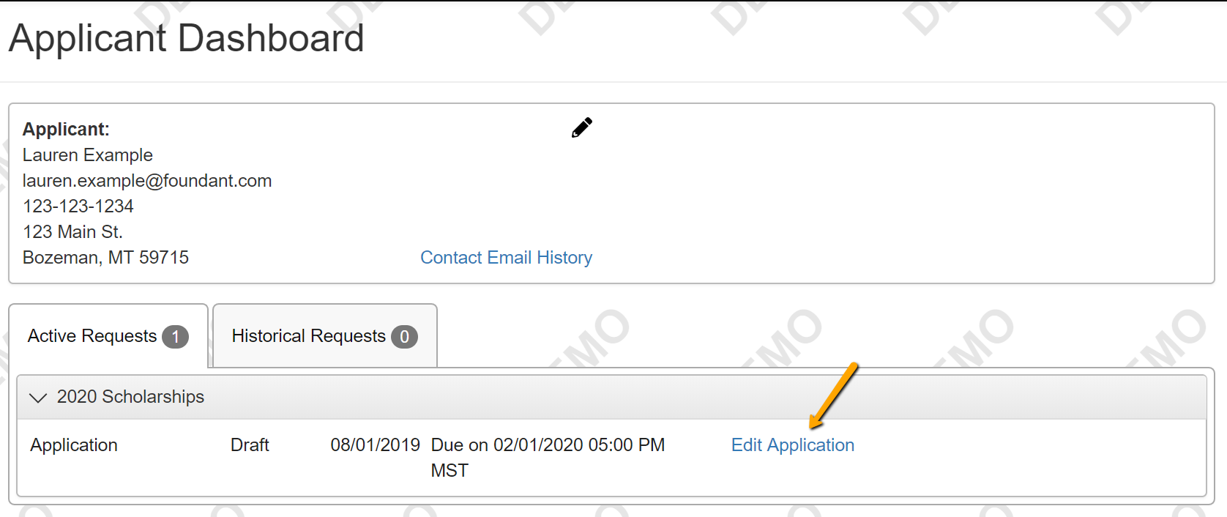

- Once you’re finished with the application, click Submit.
  - If you have not completed all required questions, the system will let you know which questions you missed.
    - All required questions must be completed to submit the application.
  - After submitting an Application, you can view it but you can’t make edits.
- Now you’ll see a confirmation page, which lists the scholarships/opportunities you’re eligible to apply for. You’ll also see a list of any scholarships that require supplemental questions.
  - The system has automatically submitted your Application for scholarships you’re eligible to apply for that do not require supplemental questions.
  - For scholarships that do require supplemental questions, you’ll have the option to complete that info and submit your Application to those scholarships as well.
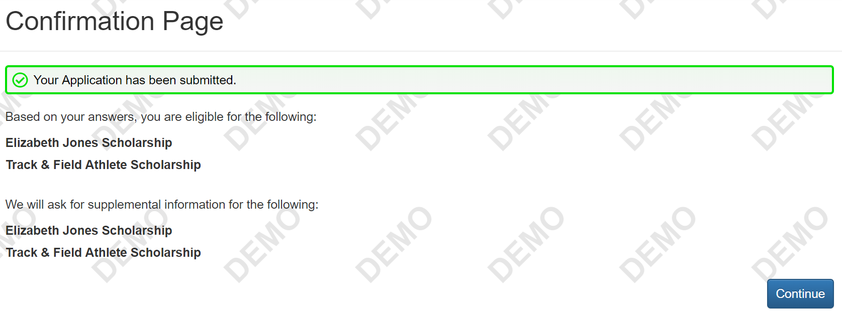
- Click Continue. You’ll be brought to the first Application with supplemental questions.
- If a supplemental question is used on more than one scholarship that you’re applying for, your response will carry across the Applications.
  - If you update your response on one Application, it will automatically update on the other Applications using that question.
- If you do not want to apply for an opportunity with supplemental questions, click Decline Opportunity.
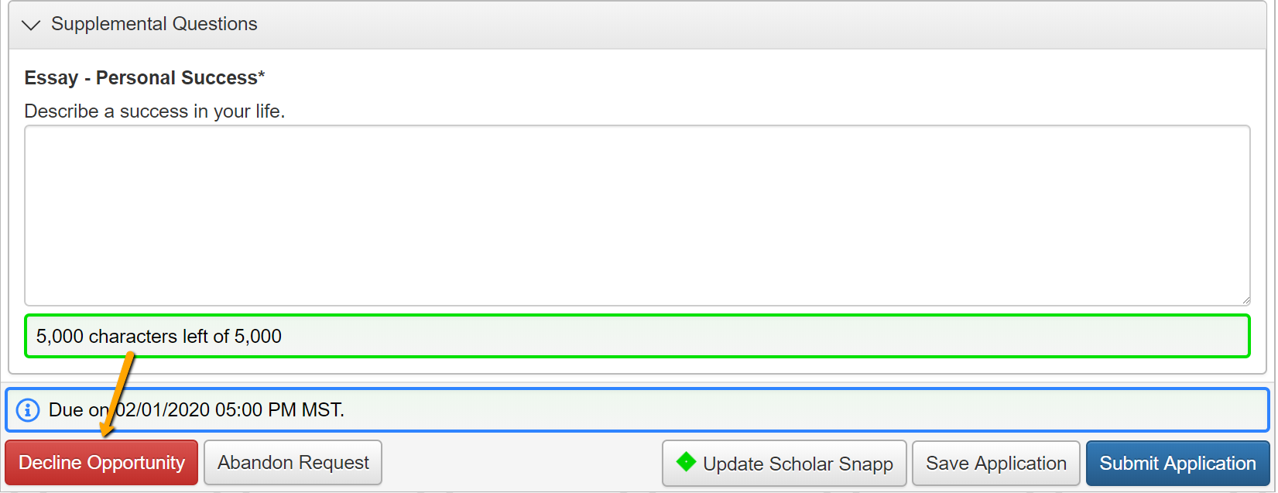
- While working on your Application, you can click Question List to download a PDF version of the questions (without your responses). You can also click Application Packet to download a PDF version of the Application with your responses, plus any documents you’ve uploaded within the form.

Your Dashboard

- When you logon to the site, you’ll land on your dashboard. You can always get back here by clicking the Home Icon in the upper navigation bar.

- You’ll see two tabs on your dashboard. The Historical tab will contain your Applications once they are no longer open or active.
- You’ll see your Applications in the Active tab as long as you’re still working on any of them, or if any of your Applications haven’t yet been approved or denied.

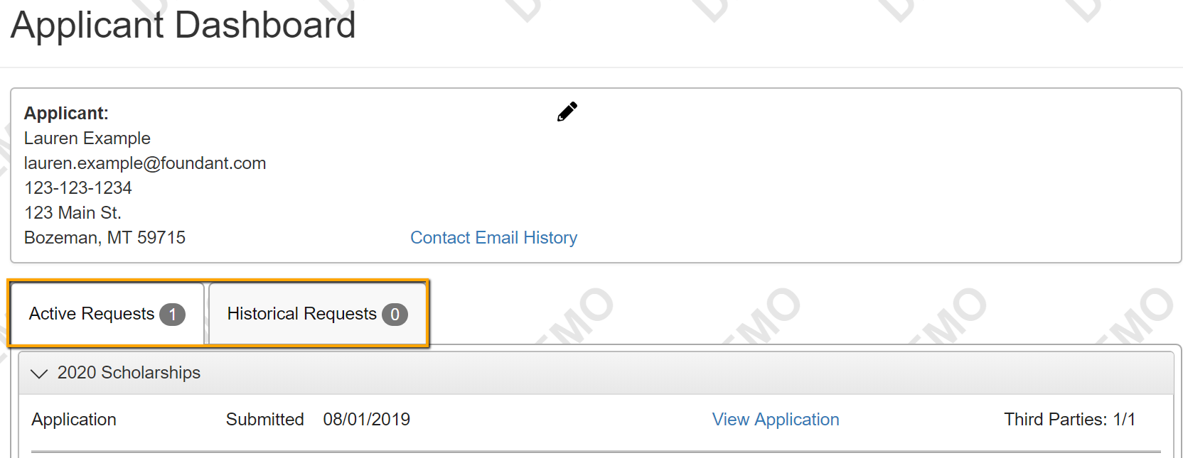
- For an approved Application, you may see a View Details link. Click this link, then the Award Details tab on the next screen to view the amount of your award and more information.
  - Some organizations may not display this information on your dashboard.
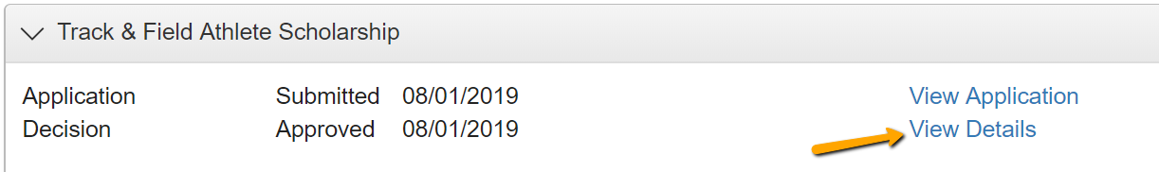
- If you’ve been assigned any Follow Up forms to complete for an award, you will see them listed at the top of your dashboard along with their due dates.

  - Click Edit next to a Follow Up form to access it.
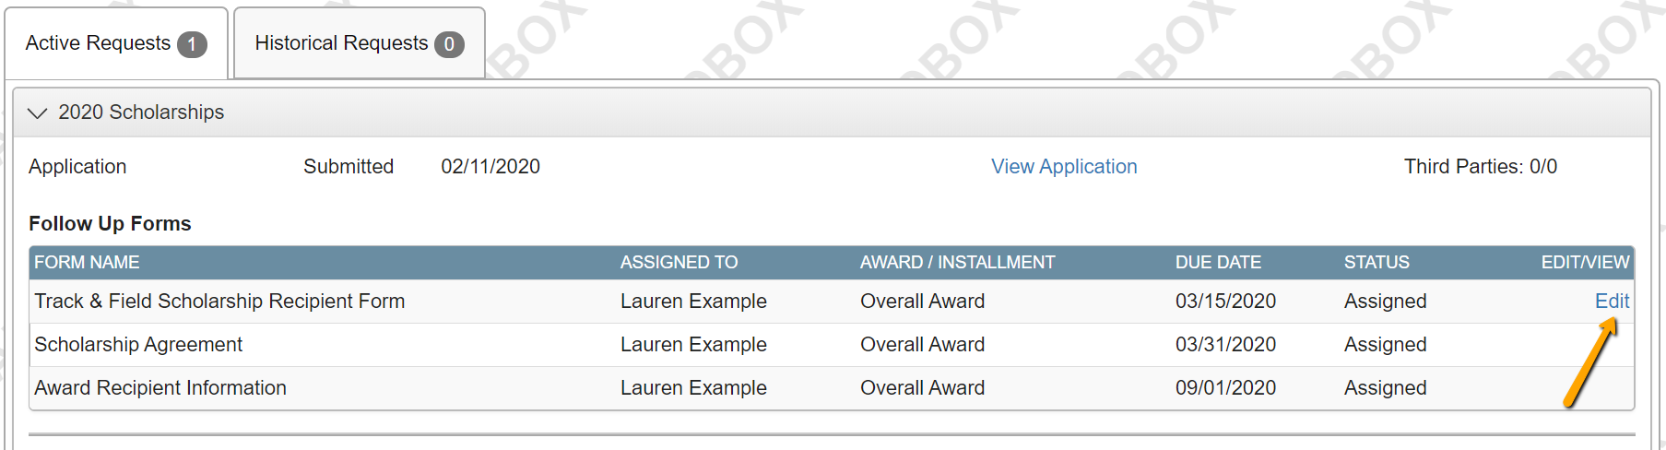
  - Just like on the Application, the system will autosave your work, and you can also click Save at any time if you need to leave the site before you’re done.
  - You may also download a PDF version of the Follow Up form questions by clicking Question List, or download a PDF version of the form with your responses by clicking Follow Up Packet.
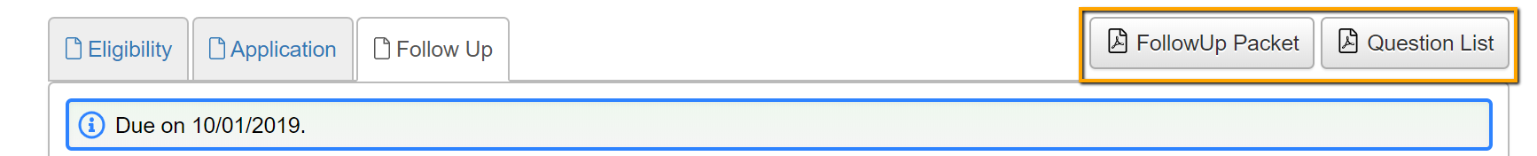
  - Click Submit when you’re done filling out the form.
- You may edit your profile at any time by clicking on your name in the upper right corner of the screen when logged on. Then click Edit My Profile.

