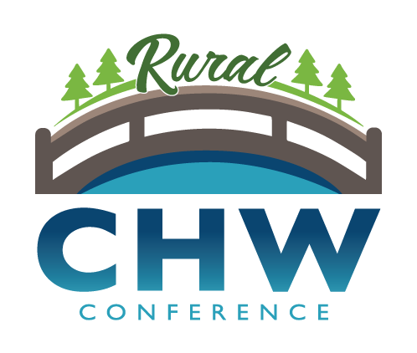 Sponsorship Agreement
Sponsor – Company name: Contact:
Address: City: _ Zip:
Phone number: Email:
Please indicate how you would like your name/company listed for recognition, or indicate anonymous:

Donation Level (indicate your choice):
_____ Platinum Sponsorship of $2500
- One exhibit table
- Ability to include promotional material in attendee welcome packet
- Five complimentary full conference registrations
- Link from Conference website to Sponsor’s website
- Prominent recognition as Host Sponsor
- Link from Conference website, logo displayed in printed program and onsite signage
_____ Gold Sponsorship of $1000
- One exhibit table
- Ability to include promotional material in attendee welcome packet
- Three complimentary full conference registrations
- Link from Conference website to Sponsor’s website
- Logo displayed in printed program and onsite signage
_____ Silver Sponsorship of $500
- One exhibit table
- Ability to include promotional material in attendee welcome packet
- Two complimentary full conference registrations
- Link from Conference website to Sponsor’s website
- Logo displayed in printed program and onsite signage
_____ Bronze Sponsorship of any lesser amount of $_______
- One complimentary full conference registration
- Logo displayed in printed program and onsite signage

Signature: ______________________________________ Date: ____________________
- Make checks payable to: Northwest Technical College
- Sponsorship forms and checks may be mailed to: Northwest Technical College, Attn: Rural CHW Conference, 905 Grant Ave. SE, Bemidji, MN 56601
- If you have questions about sponsorship or need to request an invoice please contact: Sarah Behrens, sarah.behrens@ntcmn.edu, (218) 755-4902

You will receive a follow-up email with instructions for submitting your logo and how to access any registrations.
PLEASE RETURN NO LATER THAN SEPTEMBER 1, 2021

