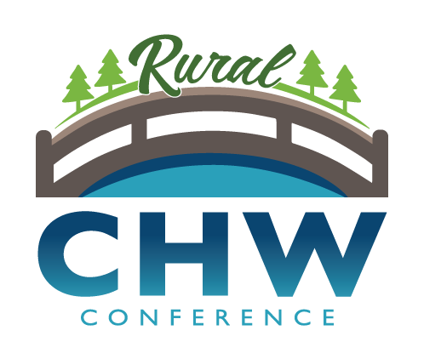
Sponsorship Opportunities for 2021
5th Annual

MN CHW Rural Health Conference
October 15, 2021

Be a part of advancing Community Health Workers in greater Minnesota!

Platinum Sponsorship of $2,500 includes:
- One exhibit table
- Ability to include promotional material in attendee welcome packet
- Five complimentary full conference registrations
- Link from Conference website to Sponsor’s website
- Prominent recognition as Host Sponsor
- Link from Conference website, logo displayed in printed program and onsite signage

Gold Sponsorship Opportunities of $1,000 includes:
- One exhibit table
- Ability to include promotional material in attendee welcome packet
- Three complimentary full conference registrations
- Link from Conference website to Sponsor’s website
- Logo displayed in printed program and onsite signage

Silver Sponsorship of $500 includes:
- One exhibit table
- Ability to include promotional material in attendee welcome packet
- Two complimentary full conference registrations
- Link from Conference website to Sponsor’s website
- Logo displayed in printed program and onsite signage

Bronze Sponsorship of any lesser amount includes:
- One complimentary full conference registration
- Logo displayed in printed program and onsite signage

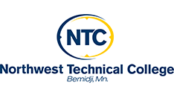

For more information and to reserve your MN CHW Rural Health Sponsorship, please contact us
NO LATER THAN SEPTEMBER 1ST, 2021
Sarah Behrens at sarah.behrens@ntcmn.edu 218-755-4902

